

Ticker: Suzlon
Industry: Renewable Energy

Equity Research Analysis
Wind Energy Sector | Renewable Energy Research Project

Renuka Hebasur

About
Suzlon Energy Ltd
Suzlon Energy is a leading global renewable energy solutions provider specializing in wind energy, with approximately 21 GW of installed capacity across 17 countries. The company operates a vertically integrated business model, covering wind turbine manufacturing, project execution, and long-term operations and maintenance (O&M) services, enabling end-to-end control over the wind energy project lifecycle.
In India, Suzlon is the No. 1 wind energy solutions provider, with over 15.1 GW of installed capacity, representing nearly 30% market share and powering 1 in every 3 wind turbines in the country. This strong domestic presence positions the company as a key enabler of India’s renewable energy transition.
The company benefits from a robust domestic manufacturing ecosystem aligned with the “Make in India” initiative, with around 75% local content, which not only strengthens supply chain resilience but also provides a competitive advantage under evolving regulatory frameworks such as domestic sourcing requirements and ALMM (Wind).
Suzlon’s product portfolio includes advanced 2.x MW and 3.x MW turbine platforms, designed to optimize energy output across diverse wind conditions in India. Its focus on reducing the Levelized Cost of Energy (LCOE) and improving turbine efficiency enhances its value proposition for both utility and commercial & industrial (C&I) customers.
Strategically, Suzlon is well-positioned to benefit from India’s accelerating wind energy capacity additions, supported by government policy, increasing corporate demand for clean energy, and the growing importance of wind in balancing solar-led renewable energy generation.

Investment Highlights:
- Turnaround story: Strong shift to profitability and net cash position
- Market leader: ~30% share in India’s wind energy market
- Policy tailwinds: Benefiting from domestic manufacturing push
- Order book visibility: 5.6 GW provides near-term revenue clarity

Business Model of Suzlon Energy
Suzlon operates a vertically integrated business model across the wind energy value chain, allowing it to capture value from manufacturing, project execution, and long-term service operations. This integrated structure enables the company to balance cyclical revenue streams from turbine sales with stable, recurring income from operations and maintenance services
🔸 1. Wind Turbine Generator (WTG) Manufacturing
The WTG segment is Suzlon’s primary revenue driver, involving the design, manufacturing, and sale of wind turbines. The company offers a range of turbines, particularly its 2.x MW and 3.x MW platforms, which are optimized for India’s diverse wind conditions.
Revenue in this segment is largely dependent on:
- New wind energy capacity additions
- Order inflows from IPPs, PSUs, and C&I customers
- Competitive pricing and technological efficiency

While this segment drives volume growth, it remains cyclical in nature, as it is closely linked to industry demand, policy support, and project commissioning timelines.
🔸 2. Project Execution (EPC / Turnkey Solutions)
Suzlon provides end-to-end wind project execution services, including site identification, land acquisition, installation, and grid connectivity. This segment plays a critical role in converting order inflows into actual revenue.
Execution capability directly impacts:
- Project timelines
- Revenue recognition
- Customer satisfaction and repeat business

🔸 3. Operations & Maintenance (O&M) Services
The O&M segment provides long-term service contracts for wind turbine maintenance, typically spanning 10–20 years. Suzlon manages a large installed base, including both its own turbines and third-party assets (through its acquisition of Renom Energy Services).

Key characteristics:
- Recurring and predictable revenue stream
- Higher margins compared to manufacturing
- Strong customer retention due to long-term contracts

🔸4. Order Book & Revenue Visibility
Suzlon has a strong order book of ~5.6 GW, providing clear medium-term revenue visibility. The order mix is diversified across:
- Commercial & Industrial (C&I) segment (~55%)
- Public Sector Undertakings (~26%)

🔸5. Key Business Drivers
Suzlon’s business performance is influenced by several external and internal factors:
- Growth in India’s wind energy capacity additions
- Government policies and auction mechanisms
- Rising demand from corporates for clean energy (C&I segment)
- Technological advancements improving turbine efficiency
- Expansion of hybrid renewable projects (wind + solar)

🔸6. Cost Structure & Margin Drivers
Suzlon’s profitability is driven by a combination of operational efficiency and strategic positioning:
- High domestic manufacturing (~75% local content) → cost advantage
- Economies of scale → improved operating leverage
- Product mix shift toward 3 MW turbines → higher margins
- O&M services contribution → stable and higher-margin revenue
.

🔸 Industry Analysis: India Renewable & Wind Energy Sector (with Concall Insights)
🔸 1. Renewable Energy Market Overview
- Total installed capacity: ~484 GW
- Renewable capacity: ~242 GW (~50%)
- Target: 500 GW non-fossil capacity by 2030
Concall Insight:
Management highlighted India crossing ~50% non-fossil capacity, confirming a structural energy transition.

🔸 2. Wind Energy Segment
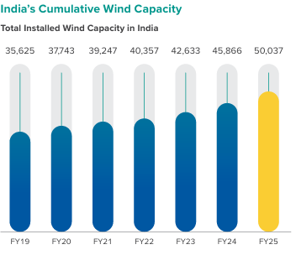
Installed wind capacity: ~51 GW

🔸 3. Growth Outlook
- Annual wind opportunity pipeline: ~15–20 GW bids
- Hybrid projects dominate:
  - Majority new tenders = wind + solar mix

🔸 4. Key Trends (From Concall – High Value)
A. Shift to Hybrid & C&I Demand
- ~60%+ order mix from C&I customers

B. Technology Shift
- 3 MW+ turbines dominate (~90% order book)

C. Policy Tailwinds
- GST on wind turbines reduced 12% → 5%
- ALMM (Wind) & import monitoring tightening

D. Execution Acceleration
- Record deliveries & commissioning pipeline improving
- H2 execution expected to be significantly stronger

Wind Energy Industry Analysis (India)
India’s wind energy sector, with ~51 GW installed capacity (~21% of renewable mix), is entering a growth phase after a slow period, with additions rising from ~3.3 GW in FY24 to ~5 GW in FY25, and expected to scale to 6–8 GW annually in the next few years. Growth is driven by India’s 500 GW renewable target, increasing C&I demand, and the shift toward hybrid (wind + solar) projects, where wind plays a key role in ensuring grid stability. The industry is also witnessing a transition to higher-capacity (3 MW+) turbines, improving efficiency and reducing costs. However, execution challenges such as land acquisition and grid evacuation delays remain key constraints. Overall, the sector is moving into a policy-supported, demand-driven expansion phase, benefiting players like Suzlon Energy.

Parameter | Data / Insight
Installed Capacity | ~56 GW (FY26)
Share in Renewable Mix | ~20–21%
Annual Capacity Addition | ~6.0–6.3 GW (record high)
Growth Trend | Scaling to ~6–8 GW annually (medium term)
Global Ranking | Among Top 3 wind markets globally
Market Growth | ~10% CAGR expected
Key Demand Drivers | Govt targets (500 GW), C&I demand, hybrid projects
Technology Trend | Shift to 3–5 MW turbines
Project Type Shift | Increasing hybrid (wind + solar) projects
Geographic Concentration | Gujarat, Tamil Nadu, Karnataka
Market Type | ~98% Onshore wind
Key Challenge | Grid evacuation & execution delays
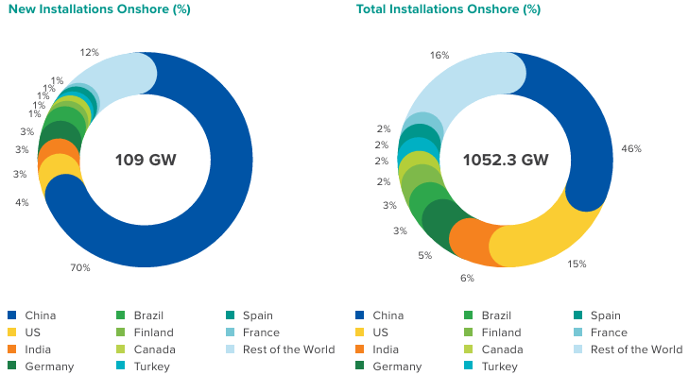
Market Snapshot – India Wind Energy Sector

🔹 Policy & Regulatory Environment – India Wind Energy
🔸 Key Policies & Impact
Policy / Initiative | Description | Impact on Wind Sector & Suzlon
500 GW Renewable Target (2030) | Government target for non-fossil capacity | Strong long-term demand visibility for wind projects
National Wind-Solar Hybrid Policy | Promotes hybrid (wind + solar) projects | Increases project viability & turbine demand
ALMM (Approved List of Models & Manufacturers – Wind) | Mandates use of approved domestic manufacturers | Favors domestic players like Suzlon
Make in India Initiative | Encourages local manufacturing | Benefits Suzlon (~75% localization) with cost advantage
GST Reduction (12% → 5%) | Lower tax on wind turbines | Improves project economics and demand
Green Open Access Rules | Easier renewable access for corporates (C&I) | Boosts demand from high-margin C&I segment
Renewable Purchase Obligations (RPOs) | Mandatory renewable procurement for DISCOMs | Ensures consistent demand for wind energy
ISTS Waiver (Transmission Charges) | Waiver for renewable projects (time-bound) | Reduces cost of power delivery, improving adoption

🔸 Policy Impact Summary (Short Paragraph)
India’s wind energy sector is strongly supported by government policies focused on capacity expansion, domestic manufacturing, and corporate renewable adoption. Initiatives such as the 500 GW renewable target, hybrid policy, and green open access rules are driving demand, while ALMM and Make in India provide a structural advantage to domestic players like Suzlon Energy. Additionally, cost-supportive measures such as GST reduction and transmission charge waivers are improving project viability. Overall, the policy environment remains a key growth enabler, though execution and regulatory consistency remain important factors to monitor.

🔹 Analyst Insight
Policy support in India is not just directional but structural, creating long-term demand visibility and a favourable competitive environment for domestic wind players.

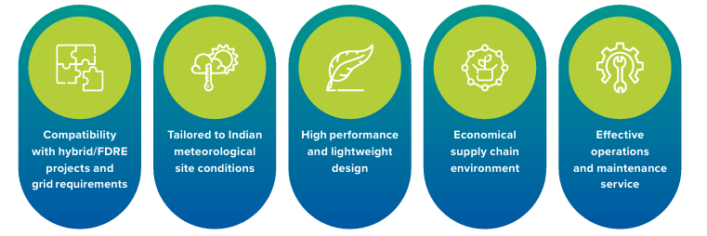

Concall Highlights – Suzlon Energy Ltd
Recent management commentary highlights a strong growth outlook for the wind energy sector, with annual installations expected to scale from ~5 GW in FY25 to ~6–8 GW over the next few years, indicating a sustained growth cycle. Suzlon reported a robust order book of ~5.6 GW, providing strong revenue visibility, with ~55–60% of orders coming from the Commercial & Industrial (C&I) segment, reflecting increasing corporate demand for renewable energy. The company is also witnessing a clear technology shift toward 3 MW+ turbines, which now form the majority of its order book and are expected to support margin improvement. Management emphasized improving execution, with stronger project commissioning expected in upcoming quarters, although grid evacuation constraints remain a key bottleneck, with certain completed projects awaiting connectivity. Additionally, Suzlon’s transition to a net cash position, along with benefits from localization and favourable policy support, indicates a strengthening balance sheet and improving profitability outlook.

Market Profile

Metric | Value
Market Cap | Rs. 68,379 Cr
Stock PE | 21.2
ROCE | 32.5%
ROE | 41.4%
No. of Eq. Share | 1,361
CMP | Rs. 50.3
High/Low | Rs. 74/38
EV/EBITDA | 16.37%

